Council Assessment Report
Panel Reference |  | PPSHCC-75
DA number |  | DA/430/2021
LGA |  | Lake Macquarie City Council
Proposed development |  | Waste and resource management facility (waste or resource transfer station)
Permissibility |  | A waste or resource transfer station is permitted with consent in the IN2 Light Industrial zone under the Lake Macquarie Local Environment Plan 2014 and also SEPP (Infrastructure).
Street address |  | 3A Pennant Street, Cardiff NSW 2285 (Lot 2401 DP 715257)
Zoning |  | IN2 Light Industrial
Applicant/Owner |  | Applicant: Central Waste Pty Ltd  Owner: Mr M Constantine
Date of DA lodgement |  | Submitted to NSW Planning Portal 11 March 2021.  Lodged with Council on 18 March 2021.
Exhibition |  | Notified 31 March to 5 May 2021.  No public submissions were received.
Integrated authorities / referral to agencies |  | - Environmental Protection Authority – Integrated Development – Protection of the Environment Operations Act 1997 - GTAs provided.  - Department of Planning, Industry and Environment – Environmental Planning and Assessment Act 1979 s4.16(9) – advice provided.  - Transport for NSW – State Environmental Planning Policy (Infrastructure) – advice provided.
Recommendation |  | Approval, subject to conditions of consent.
Regional Development Criteria (Schedule 7 of the SEPP (State and Regional Development) 2011 |  | 7(c) waste management facilities or works, which meet the requirements for designated development under clause 32 of Schedule 3 to the Environmental Planning and Assessment Regulation 2000.
List of all relevant s4.15(1)(a) matters |  | - State Environmental Planning Policy (State and Regional Development)  - State Environmental Planning Policy (Infrastructure)  - State Environmental Planning Policy No. 55 – Remediation of Land  - Lake Macquarie Local Environmental Plan 2014  - Lake Macquarie Development Control Plan 2014  - Environmental Planning and Assessment Regulations clause 93 and 94
List all documents submitted with this report for the Panel’s consideration |  | Attachment A: Draft conditions of consent  Attachment B: Plans
Clause 4.6 request/s |  | None.
Summary of key submissions | Traffic impacts  - Split of traffic to alternate route during peak times.  - Limitation on the largest vehicle used by the development.  - Maximum capacity of the site.  - Traffic management plan  Parking  - Line marking of parking spaces to provide for 13 vehicles.  Environmental concerns  - Air quality impact.  - Noise impact.  - Water management.  SEARs  - Department of Planning – no issues.
Report prepared by |  | Geoffrey Keech, Senior Development Planner
Report date |  | 13 July 2021

Summary of s4.15 matters  Have all recommendations in relation to relevant s4.15 matters been summarised in the Executive Summary of the assessment report? | Yes
Legislative clauses requiring consent authority satisfaction  Have relevant clauses in all applicable environmental planning instruments where the consent authority must be satisfied about a particular matter been listed, and relevant recommendations summarised, in the Executive Summary of the assessment report? | Yes
Clause 4.6 Exceptions to development standards  If a written request for a contravention to a development standard (clause 4.6 of the LEP) has been received, has it been attached to the assessment report? | Not Applicable
Special Infrastructure Contributions  Does the DA require Special Infrastructure Contributions conditions (S7.24)? | No
Conditions  Have draft conditions been provided to the applicant for comment? | Yes

Executive summary
Consent is sought for a waste or resource transfer station, providing consolidation and sorting activities prior to transfer to a processing facility.
The development reuses the existing infrastructure onsite from the site’s previous use as the Ingham’s grain handling facility. Works include minor upgrades for fire safety, internal rollover bund, and line marking of car parking. No other works are proposed.
The application was exhibited from 31 March to 5 May 2021. No submissions were received.
An Environmental Impact Statement (EIS) has been prepared, notified, and forwarded to the Planning Secretary and Environmental Protection Authority in accordance with the Environmental Planning Assessment Act and Regulations.
General Terms of Approval (GTAs) have been provided by the Environmental Protection Authority (EPA) as integrated development under the Protection of the Environment Operations Act 1997.
The Department of Planning, Industry and Environment (DPIE) and Transport for NSW (TfNSW) were notified of the application. The DPIE noted no issues with the application. TfNSW did not object to the development, and provided comments for Council’s consideration, mostly relating to conditioning the development to the limits listed in the EIS, and also requesting a traffic management plan to be approved by Council prior to the issue of an Occupation Certificate.
While the land is located within a mine subsidence district, no works triggering an integrated referral to Subsidence Advisory NSW (SA NSW) are proposed. The application was not referred to SA NSW.
The development has been assessed to be compliant with applicable State, Regional and Local Environmental Planning Instruments and Policies, in accordance with Section 4.15(1) of the Environmental Planning and Assessment Act 1979. Planning instruments addressed within this report include:
- Environmental Planning and Assessment Act 1979 (EPA Act)
- Environmental Planning and Assessment Regulation 2000 (EPA Regs)
- State Environmental Planning Policy (State and Regional Development)
- State Environmental Planning Policy No. 55 – Remediation of Land
- State Environmental Planning Policy (Infrastructure) 2007
- Lake Macquarie Local Environmental Plan 2014 (LMLEP 2014)
- Lake Macquarie Development Control Plan 2014 (LMDCP 2014)
The site has no known contamination and is considered suitable for use as a waste transfer station in accordance with State Environmental Planning Policy No. 55 – Remediation of Land.
The site stormwater drains via existing infrastructure and an easement to a nearby creek. The development will process waste inside the shed, which minimises any risk of waste entering the stormwater system. A new internal rollover bund is also proposed to mitigate any spills or contaminants entering the stormwater system.
Air quality was reviewed by the EPA and deemed acceptable. Misters will be used within the building to reduce dust risk.
Noise emissions were reviewed by the EPA and are considered to meet the Noise Policy for Industry. The site is located within an established infrastructure zone, and there are no nearby sensitive receivers located near the proposed activity.
Sufficient space is available onsite for all required car, motorbike, bicycle, and accessible parking requirements, as well as all required truck manoeuvres. Line marking is proposed to formalise the required car parking within the site.
The development satisfies fire safety requirements under the EPA Regs, subject to a condition of consent requiring the prevention of firefighting suppression water from entering the stormwater system. The proposed design adequately achieves this requirement. The development is capable of compliance with the NSW Fire and Rescue “Fire Safety in Waste Facilities” guidelines.
The development is considered to be in the public interest and worthy of support subject to conditions.

Reasons for determination
The development has been assessed against the matters for consideration that apply to the land to which the development application relates as outlined in Section 4.15 of the Environmental Planning and Assessment Act, 1979 as follows:
- the development meets the requirements of the LMLEP 2014 and other relevant environmental planning instruments.
- the development generally complies with LMDCP 2014 with any variations to the controls outlined and justified within this assessment report.
- considering the likely impacts of the development on the natural and built environments, the development is considered to provide balanced and appropriate outcomes.
- the suitability of the site for the development, including characteristics and constraints of the land have been considered and it was found the land as being suitable for the development.
- matters of public interest have been considered in relation to social, economic and environmental outcomes.
Based on the balance of the matters considered, the development application is recommended for approval. Details of the assessment are contained in the assessment report below.

Community interest
The assessment of the proposed development under Section 4.15(1) of the Environmental Planning and Assessment Act, 1979 has considered the community views.
The development application was exhibited in accordance with the Lake Macquarie Community Participation Plan from 30 March to 5 May 2021.
No submissions were received in response to the public notification of the development.
Community views however were taken into consideration with the development being assessed against the provisions of the LMLEP 2014 and LMDCP 2014, both of which have been publicly exhibited and adopted by Lake Macquarie City Council.

Site, context and development history

Site and locality
The site is a battle-axe lot, with vehicle access to Pennant Street.
Existing development on the site, which will be retained and utilised for the proposed activity includes:
- Storage shed (36.8m x 60.7m)
- Three grain storage silos
- Grain transfer shed
- Amenities building
- Kitchenette and control room
- Weighbridge and office
- Paved driveway, circulation road and parking.
The locality is zoned light industrial, as shown in Figure 1. The Great Northern Railway is located 225m to the north, with Stockland Glendale shopping centre located on the northern side of the railway. Residential dwellings are located 265m north and 500m south-west of the site, with an operating or proposed childcare facilities located 750-850m east and north-east.

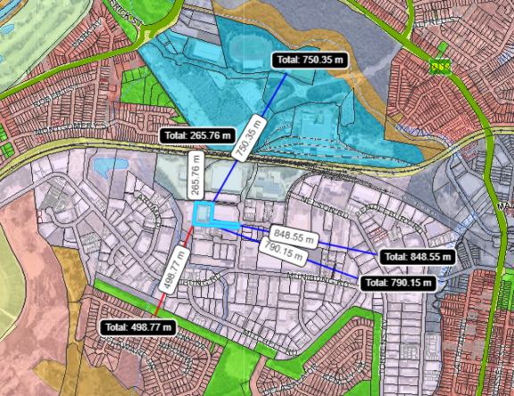
Figure 1: Map of site and surrounding land uses and zones
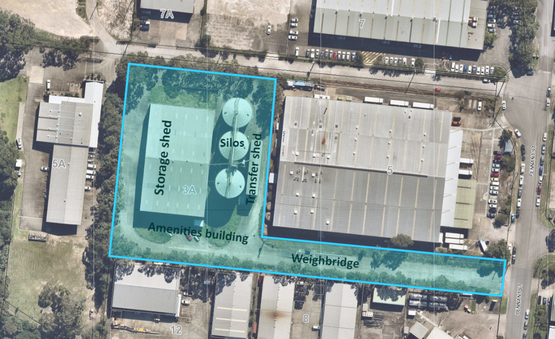
Figure 2: Aerial photo showing site features

Development history
The site was subdivided in June 1985, separating the vacant northern part of the site from the southern part, which was in use as an industrial spray painting and sand blasting facility. The Ingham’s grain storage facility was established shortly thereafter and is the only development on the land prior to the current application. All infrastructure on the site was established by the Ingham’s development and remains in place.
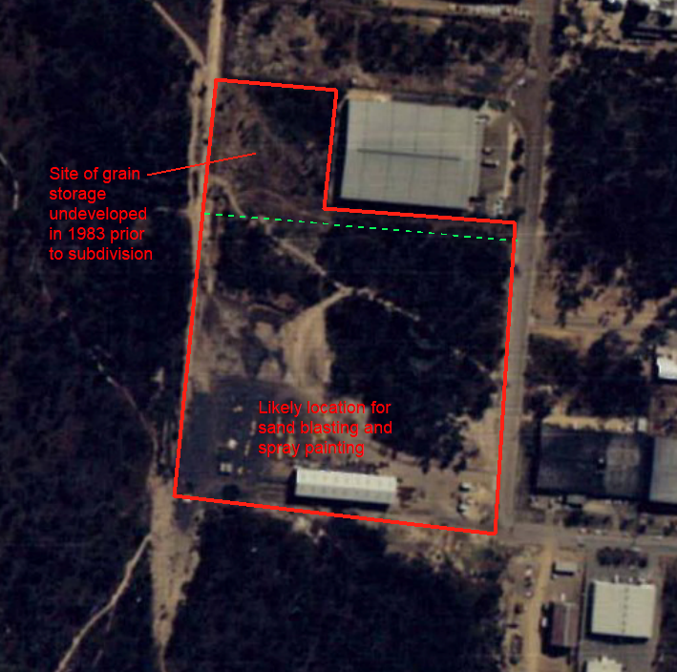
Figure 3: Council records for industrial sand blasting and spray painting relate to the shed at the south end of the pre-subdivided site

DA/668/2020 was lodged for a waste or resource transfer station on 12 May 2020 and an assessment commenced. The development proposed a throughput capacity smaller than the threshold for regionally significant development. As the development was sited within 100m of a natural watercourse, it was classified as Designated Development, but an Environmental Impact Statement had not been prepared. The application was withdrawn so that the Secretary’s Environmental Assessment Requirements process could be undertaken. The current application is the result of that process, including the opportunity to increase the throughput capacity, which also triggers regional significance.
A Pre-lodgement meeting was held with Council on 20 November 2019, prior to the lodgement of DA/668/2020. No further pre-lodgement consultation occurred prior to the lodgement of the current application.

Proposal
Consent is sought for a waste or resource transfer station, providing consolidation and sorting activities prior to transfer to a processing facility. Storage and handling of waste will occur inside the existing shed on the site.
Waste to be managed at the facility is classified general solid waste (non-putrescible). No hazardous, putrescible, liquid, special or restricted wastes will be accepted.
The proposed total capacity of the site is limited to 99,800 T/yr throughput. A maximum of 10,000 T is proposed onsite at any one time.
The development reuses the existing infrastructure onsite from the site’s previous use as the Ingham’s grain handling facility.
Works include minor upgrades for fire safety, internal rollover bund, and line marking of car parking. No other works are proposed.
The site proposes to operate 24 hours / 7

Designated development
A waste or resource transfer facility is a type of waste management facility or works. The EPA Regs Schedule 3 classifies as designated development any waste management facility or works that:
32(1)(b) sort, consolidate or temporarily store waste at transfer stations or materials recycling facilities for transfer to another site for final disposal, permanent storage, reprocessing, recycling, use or reuse and
(iii) that have an intended handling capacity of more than 30,000 tonnes per year of waste such as glass, plastic, paper, wood, metal, rubber or building demolition material.
or,
32(1)(d) that are located
(i) in or within 100 metres of a natural waterbody, wetland, coastal dune field or environmentally sensitive area.
This development is located less than 100m from a natural creek, and will sort more than 30,000 tonnes per annum of waste.
The development obtained the Secretary’s Environmental Assessment Requirements (SEARs) prior to the preparation of the Environmental Impact Statement. The SEARs identified strategic and statutory context, suitability of the site, waste management processes, hazards, fire and incident management, air quality and odours, noise and vibration, soil and water, traffic and transport, visual impact, and heritage impacts as matters to be addressed in the EIS. The application addresses the matters raised in the SEARs.
Following the closure of the exhibition period, Council advised Department of Planning, Industry and Environment there were no submissions received. Department of Planning, Industry and Environment advised that no matters of state significance apply to this proposal.

Integrated development

Coal Mine Subsidence Compensation Act 2017

Section 22 Approvals for development within mine subsidence districts
The application is located within a mine subsidence district. Guideline 8 applies to this site, for which there are no restrictions on development. The application proposes no new building work of relevance to the Coal mine Subsidence Compensation Act 2017, and the application was not referred to Subsidence Advisory NSW (SA NSW).

Protection of the Environment Operations Act 1997

Sections 43(b), 48 and 55 Environment protection licence to authorise carrying out of activities at premises described as a waste facility
The application was lodged as integrated development and the proposal was referred to the Environmental Protection Authority (EPA). The EPA requested additional information relating to air quality, noise, and water management. The applicant provided additional information on 11 June 2021, which was referred back to the EPA. The EPA provided General Terms of Approval (GTAs) dated 21 June 2021, which outlined conditions that will be imposed on the licence. Certain matters relating to noise, air quality and water quality are included as recommended conditions of consent.

Section 4.15: Potential matters for consideration
Applicable State, Regional and Local Environmental Planning Instruments and Policies are detailed hereunder. Where not explicitly detailed, it is considered those instruments or policies are not relevant to the proposal.

Section 4.15 (1) (a) (i) the provisions of any EPI’s

State Environmental Planning Policy (State and Regional Development)
The proposal is identified as regionally significant development under Part 4 Regionally significant development and Schedule 7 of the SEPP as the development meets the classification of a waste management facility that is designated development.
The Hunter and Central Coast Regional Planning Panel will be the consent authority for the application.
The development is not State Significant Development as it does not exceed the relevant throughput threshold, waste types, or activity types, nor is an identified site or project type.

State Environmental Planning Policy (Infrastructure)

Part 3, Division 23 Waste or resource management facilities
Under clause 121 development for a waste or resource transfer station may be carried out with consent on land in the IN2 Light Industrial Zone.

Part 3, Division 17 Roads and traffic, Subdivision 2 Development in or adjacent to road corridors and road reservations
Under clause 104 traffic-generating development, a waste or resource management facility of any size or capacity is traffic generating development.
Accordingly, written notice was given to TfNSW of the proposal. TfNSW provided a response on 2 July 2021, which raised no objection to the development and provided comments for Council’s consideration during the assessment and draft conditions. The comments recommended conditions of consent to limit the development to the capacity and vehicle movements noted in the EIS, as well as Council approving a Traffic Management Plan prior to occupation. Council has considered the comments and relevant matters are addressed in the draft conditions of consent.
Consideration must also be given to accessibility of the site, opportunity to maximise movement of freight in containers, and any potential traffic safety, road congestion or parking implications. The site is located in an industrial area with key connections to the state road network servicing the Newcastle-Lake Macquarie area. Waste is delivered by truck to the site from multiple locations across the local area for sorting and consolidation closer to the source of the waste. The local road network has been designed for the type of large vehicles required for this development.
The development proposes an activity which will provide efficiencies for waste processing at the off-site processing facility, which will reduce overall truck movements. Traffic and parking have been considered and are considered to be acceptable and not have impacts to safety, road congestion.

State Environmental Planning Policy 55 – Remediation of land
Under clause 7, a consent authority must not consent to the carrying out of any development on land unless it has considered whether the land is contaminated.
The site is not registered as contaminated. The lot, prior to its subdivision in 1985, was used for industrial spray painting and sand blasting. This activity occurred at the south end of the site approximately 150m distant from the existing boundary (refer Figure 3). Following this, the first development on the site was a grain storage and handling facility, constructed in the mid-1980s which is unlikely to have residual contamination.
The application does not propose any demolition or ground disturbance. The application does not propose a sensitive use/activity. The land is unlikely to be contaminated and the land is suitable for the proposed development.

Lake Macquarie Local Environmental Plan 2014

Part 2 – Permitted or prohibited development
The development is a waste or resource transfer station. Waste or resource transfer station are a type of waste and resource management facility, which is permitted in the IN2 Light Industrial zone subject to development consent.
The objectives of the IN2 zone are:
- To provide a wide range of light industrial, warehouse and related land uses.
- To encourage employment opportunities and to support the viability of centres.
- To minimise any adverse effect of industry on other land uses.
- To enable other land uses that provide facilities or services to meet the day to day needs of workers in the area.
- To support and protect industrial land for industrial uses.
- To enable ancillary commercial uses if such uses will not undermine the function of existing and future urban centres.
The development provides for a land use that is compatible with the surrounding light industrial uses. These include a service station, warehouses, construction materials supply stores, and motor vehicle related businesses.
The development provides employment opportunities, and its proximity to Cardiff and Glendale will support the function of these existing urban centres.

Clause 7.21 Essential services
The consent authority must not grant consent unless it is satisfied the required essential services are available to serve the development.
The development has demonstrated the site has, and is capable of being provided with required essential services and infrastructure including water, sewer, electricity, stormwater and vehicle access.

Given the limited works proposed, there are no development standards, miscellaneous provisions or other local provisions applicable to this development under LMLEP 2014.

Section 4.15 (1) (a) (ii) the provisions of any draft EPI
No draft EPI’s apply to the development or the site.

Section 4.15 (1) (a) (iii) DCP’s

Lake Macquarie Development Control Plan 2014

Part 5 – Development in Industrial, Business Park & Infrastructure Zones

2.7 Stormwater management and 2.10 Natural water systems
Stormwater management arrangements are proposed to remain as current that comprises drainage from hardstand areas being directed to kerb inlets, which drain to the nearby creek via an existing easement across the neighbouring Lot 9 DP 806924.
A new rollover bund will be constructed internal to the building which will prevent firefighting water from entering the stormwater system, and also mitigate any spills or contaminants entering the stormwater system. All waste handling is to occur within the building, which significantly reduces any chance of stormwater contamination. No washdown activities are proposed at the site.

2.13 Preservation of trees and vegetation
The site includes mature trees to the boundaries. No works are proposed that will impact the health or viability of this vegetation.

2.20 Social impact
A program of engagement by the applicant during preparation of the application identified nearby landowners potentially affected by the development. Prior to lodgement of the application, the applicant distributed a newsletter to nearby landowners. Local aboriginal groups were also consulted.
No submissions were reported from the engagement process, nor were any received during the exhibition period of the application.

3.11 Traffic and transport
A Traffic Impact Assessment report was submitted with the application.
Access arrangements to the site comprise an existing concrete driveway from Pennant Street and will be retained. These arrangements are considered suitable for the development.
Sufficient space has been demonstrated for parking provision inclusive of manoeuvring for heavy vehicles through the site.
The development utilises heavy vehicles as an integral part of its operations. Vehicles will traverse Pennant Street and then Munibung Road east (mostly) or west (during peak periods) to get to the nearest State road.
The use of heavy vehicles on the local road network will attract haulage levies.
The application was referred to Council’s Traffic Engineer who was supportive of the proposal, subject to conditions of consent.
The application was referred to TfNSW who recommended consideration of total throughput limitation, size and frequency limitations, route restrictions during peak periods, car parking, and the development of a Traffic Management Plan. Conditions are recommended to limit the site throughput capacity, the largest vehicle servicing the development, and development of a traffic management plan including specification peak hour routes. Daily truck movements data was an average figure and is not considered appropriate to condition as a maximum figure.

3.12 Design of car parking and service areas, 3.13 Bike parking facilities, 3.14 Motor bike parking, and 3.15 Car parking rates
The operation predicts employment of 25 staff, of whom a maximum of 11 will be present onsite at any one time. No parking rates are specified in the DCP for waste management facilities, however industrial uses require 1 space per 100m² GFA. This returns a requirement of 23 spaces, which should include one accessible space.
A waste or resource transfer station differs from a regular industrial use, and an alternative parking rate has been proposed. The application proposes a total of 13 spaces, inclusive of one accessible space. This represents one space per employee plus two additional spaces. This rate is considered reasonable to provide for employee parking, as vehicles accessing the site for commercial purposes are accommodated within the loading bays.
Secure, undercover bicycle and motorbike parking can be accommodated in the transfer shed, while shower facilities are provided in the amenities building.

3.17 Safety and security
The site is fully fenced. Materials are stockpiled inside the storage shed, eliminating their visibility and increasing the difficulty of theft for any valuable wastes. Most waste is transferred offsite each day.
The safety and security features of the site are considered appropriate for the development.

4.2 Operational waste management
Notwithstanding the waste managed by the development, the staff will generate a small quantity of general waste. This can be accommodated in regular waste bins and collected either by Council or private contractors.

4.6 Air quality
An Air Quality Impact Assessment was lodged with the application, and reviewed by the EPA and Council’s Environmental Management Officer.
The applicant proposes to include misters at the shed entries to reduce the risk of airborne dust.
Conditions of consent are recommended which are derived from the EPA’s GTAs.

4.7 Noise and vibration
A Noise Impact Assessment was submitted with the application, and reviewed by the EPA and Council’s Environmental Management Officer.
The development will generate noise through the use of trucks, the loading and unloading of skip bins, and the movement of waste when sorting.
Conditions of consent are recommended relating to maximum noise levels and certification, which are derived from the EPA’s GTAs.

Section 4.15 (1) (a) (iv) any matters prescribed by the regulations
EPA Regs Clauses 93 Fire safety and other considerations & 94 Consent authority may require buildings to be upgraded
Cl. 93 This clause applies to a development application for a change of building use for an existing building where the applicant does not seek the rebuilding, alteration, enlargement or extension of a building.
In determining the development application, the consent authority is to take into consideration whether the fire protection and structural capacity of the building will be appropriate to the building’s proposed use.
Cl. 94 This clause applies to a development application for development involving the rebuilding, alteration, enlargement or extension of an existing building where the measures contained in the building are inadequate to protect persons using the building, and to facilitate their egress from the building, in the event of fire.
In determining a development application to which this clause applies, a consent authority is to take into consideration whether it would be appropriate to require the existing building to be brought into total or partial conformity with the Building Code of Australia.

The development is a change of use from a grain handling facility to a waste or resource transfer station, utilising the existing building.
A fire safety assessment report was submitted with the application, which assessed the proposed development against the NSW Fire + Rescue Fire safety in waste facilities guidelines. The report recommended works to upgrade the fire safety of the building, and the application incorporates these works. No other works are proposed.
The application was referred to Council’s Building Surveyor, who advised the building and proposed fire safety measures are suitable for the change of use.
The proposed upgrades from the fire safety report have been included in the recommended draft conditions of consent.

Section 4.15 (1) (b) the likely impacts of the development

The likely impacts of the development contained in this part of the Act have been detailed throughout the assessment report.

Section 4.15 (1) (c) the suitability of the site for development

Does the proposal fit the locality?
It is considered the development fits the locality.
The site is located within an existing industrial zone, which is generally intended for such uses. Sensitive receivers are located appropriate distances away and are unlikely to be impacted by the proposal.

Are the site attributes conducive to development?
As demonstrated in this report, the site is conducive to the development proposed.
The development reuses existing infrastructure with minimal modification. It does not prevent the future use of the site for alternative uses.

Section 4.15 (1) (d) any submissions made in accordance with this Act or the Regulations?
The application was exhibited from 31 March to 5 May 2021. No submissions were received.

Section 4.15 (1) (e) the public interest
The development is considered to achieve balanced and orderly outcomes, and is in the public interest.
The application provides a development that is consistent with the zoning of the land and has demonstrated compliance with relevant controls.
The establishment of a waste transfer station will reduce overall truck movements during processing, and allow for more efficient processing of waste. The development repurposes existing structures, minimising resource wastage involved in demolition/construction work.
The development has demonstrated no significant amenity impacts will arise now or in the future, subject to the imposition and compliance with recommended conditions of consent.

Section 7.11 Contribution towards provision or improvement of amenities and services
The site is located within the Glendale Catchment Contribution Plan. The application was referred to Council’s Local Development Contributions Officer. The development is not subject to a development contribution for the provision of amenities or services, however is subject to heavy vehicle haulage levies. Conditions will be imposed requiring the arrangements and payment of these levies.

Staff Endorsement
The staff responsible for the preparation of the report, recommendation, or advice to any person with delegated authority to deal with the application has no pecuniary interest to disclose in respect of the application.
The staff responsible authorised to determine the application have no pecuniary interest to disclose in respect of the application. The report is enclosed and the recommendation therein adopted.
Signed:
Geoffrey Keech
Development Planner
Development Assessment and Certification

Senior Endorsement
The staff responsible for the preparation of the report, recommendation, or advice to any person with delegated authority to deal with the application has no pecuniary interest to disclose in respect of the application.
The staff responsible authorised to determine the application have no pecuniary interest to disclose in respect of the application. The report is enclosed and the recommendation therein adopted.
Signed:
Amy Regado
Section Manager Development
Development Assessment and Certification

